**Assignment**

**NASA Astronomy Picture of the Day Mobile Application**

Contents

Introduction 3

Marks 3

Creation of the Ionic App 3

Submission of the Ionic App 3

Teams 4

App Structure 5

Technical Details 6

Application in action 6

### **Introduction**

Each day NASA releases an [Astronomy Picture of the Day](https://api.nasa.gov/api.html#apod). This picture can be accessed as described in the above link.

You will need an API key to access the Picture of the Day JSON feed, this can be obtained at the following address:

<https://api.nasa.gov/index.html#apply-for-an-api-key>

You are required work in teams (described below) to write an Ionic application that connects to the website and downloads the picture for one of the following options:

* Today
* The previous seven days
* The previous fourteen day

### **Marks**

This assignment is worth 20% of the marks for the module.

### **Creation of the Ionic App**

The application should be created as follows:

* ionic start GXXXXXXX1_GXXXXXXX2 blank

Where GXXXXXXX1 is your student number of the first student in the team,

and GXXXXXXX2 is the student number of the second student in the team etc.

### **Submission of the Ionic App**

The zipped Ionic application (with the filename as described above) should be uploaded to the Assignment 1 section of Moodle no later than 9:00am on **Friday December 2nd 2016**.

### **Teams**

|  |
| --- |
| Teams |
| Dorothy Cassidy (G00180994)  Larisa Galiseva (G00341287)  Marie O’Hara (G00013745) |
| Martin Gibbons (G00341289)  John Kelly (G00253600) |
| Liam Foley (G00341276)  Alex Acquier (G00293624) |
| Sharon Costello Desmond (G00177850)  Leonard Reidy (G00341288) |
| James Taylor (G00012318)  Brendan Travers (G00253985) |
| Leighvi Keenan (G00341279)  Deirdre Weldon (G00341284)  Fionn Loftus (G00329882) |
| Pierce Jordan (10011177)  Alan Kennedy (10002055) |
| Catherine Gaughan Smith (G00341282) |
| Armon Chojnacki (G00341278)  Kelly Osawaru (G00264956) |

### **App Structure**

The application should consist of an index.html file where the body consists only of the following:

<body ng-app="myNews">

<ion-nav-view></ion-nav-view>

</body>

There should be two template files one which displays the data received from the NASA server and should look as follows:

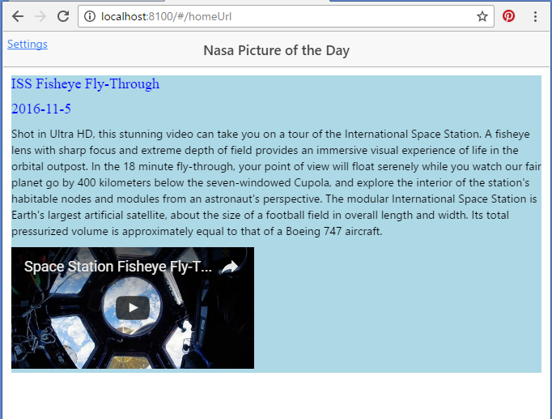

The other template file should contain “settings” and look as follows:

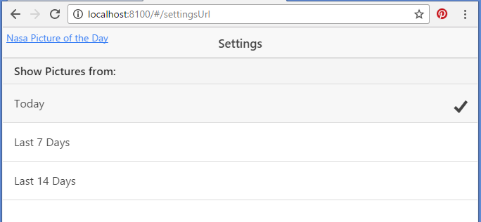

### **Technical Details**

There should be a State for each view.

The data from the NASA server should be retrieved using a Service.

The following parts of the NASA server’s response should be shown:

* Title of the Image
* Date of the Image
* Explanation of the Image
* The Image or Video itself

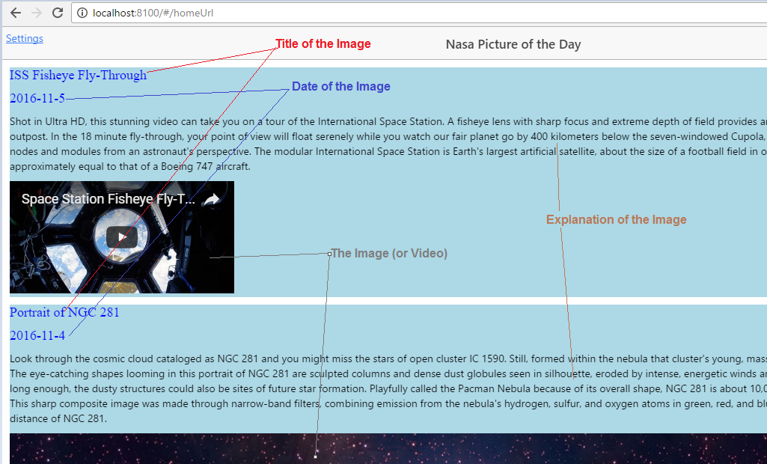

When the user changes the number of days to show images for (on the settings page) this should be reflected immediately when the user returns to the home page.

### **Application in action**

Download *Demonstration of Project 1.webm*from the Assignment 1 section of Moodle and open it in a web browser to see a working version of how the finished assignment should look